Michele Speidel

6/12/2022

Module 3_2 Assignment

PyBookCo

CSD310-330H_2225_DD

Database Development and Use

1. Convert the provided data fields into a normalized ORD

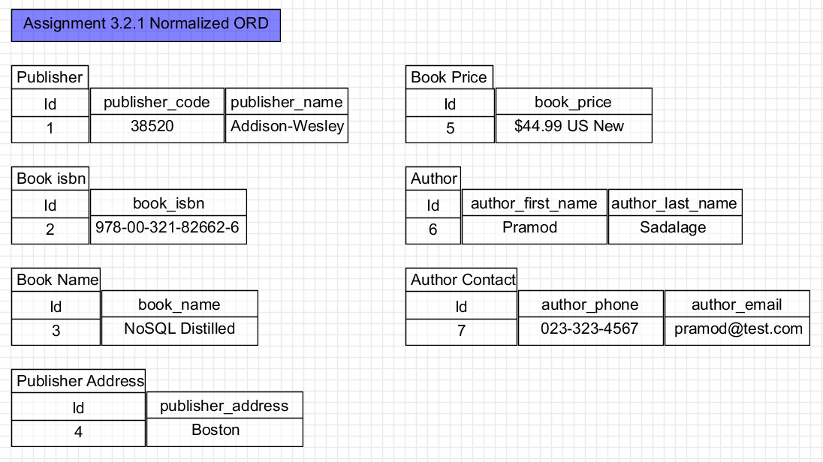

1. Convert the normalized ORD to a NoSQL document diagram

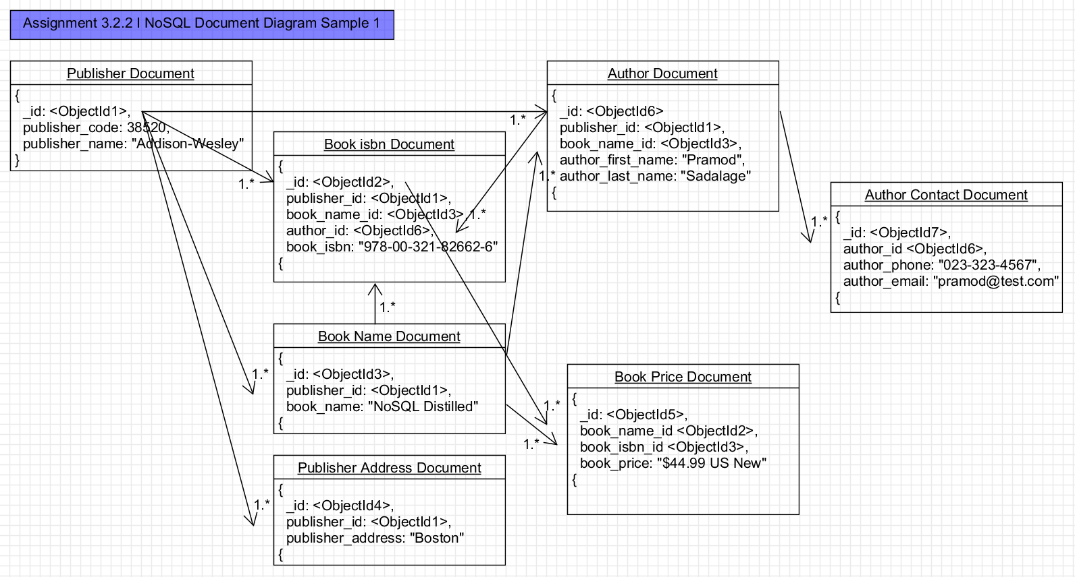

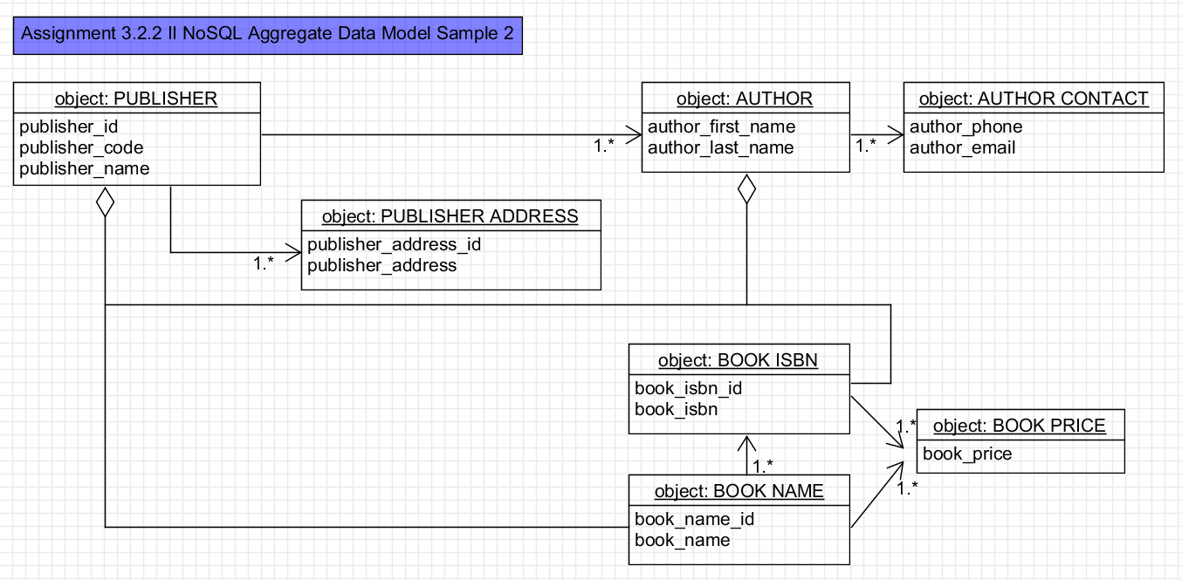

1. Create a NoSQL data structure
2. Supply your own default values

Assignment 3.2.3 NoSQL Data Structure

Assignment 3.2.4 Supply Your Own Default Values

// in publisher

{

“publisher”: {

“id”: 1,

“publisher_code”: 38520,

“publisher_name”: “Addison-Wesely”,

"author": [

{

"id": 6,

"publisher_id": 1,

"book_name_id": 3,

"author_first_name": "Pramod",

"author_last_name": "Sadalage"

"book_isbn": [

{

"id": 2,

"publisher_id": 1,

"book_name_id": 3,

"author_id": 6

"book_name": [

{

"id": 3,

"publisher_id": 1,

"book_name": "NoSQL Distilled",

"book_price": [

{

"id": 5,

"book_name_id": 2,

"book_isbn_id": 3,

"book_price": "$44.00 US New"

},

{

“id”:11,

“book_price”: “$55.99 Canada New",

}

“publisher_address”: [

{

“id”: 4,

"publisher_id": 1,

“publisher_address”: “Boston”

},

{

“id”: 12,

“purblisher_address”: “Toronto”,

"author": [

{

"id": 6,

"publisher_id": 1,

"book_name_id": 3,

"author_first_name": "Promod",

"author_last_name": "Sadalage"

},

{

"id": 10,

"author_first-name": "Martin",

"author_last_name": "Fowler"

}

"author_contact": [

{

"id": 7,

"author_id": 6,

"author_phone": "023-323-4567",

"author_email": "pramod@test.com"

]

}]

}]

]

}]

}

}

1. Create business rules to support your diagrams

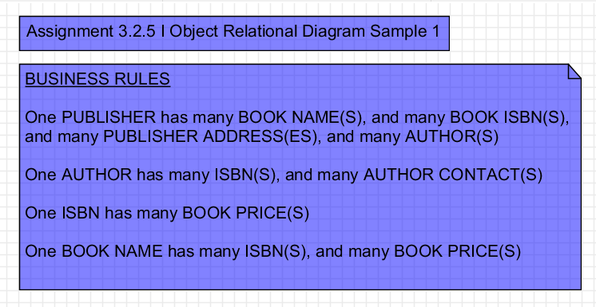

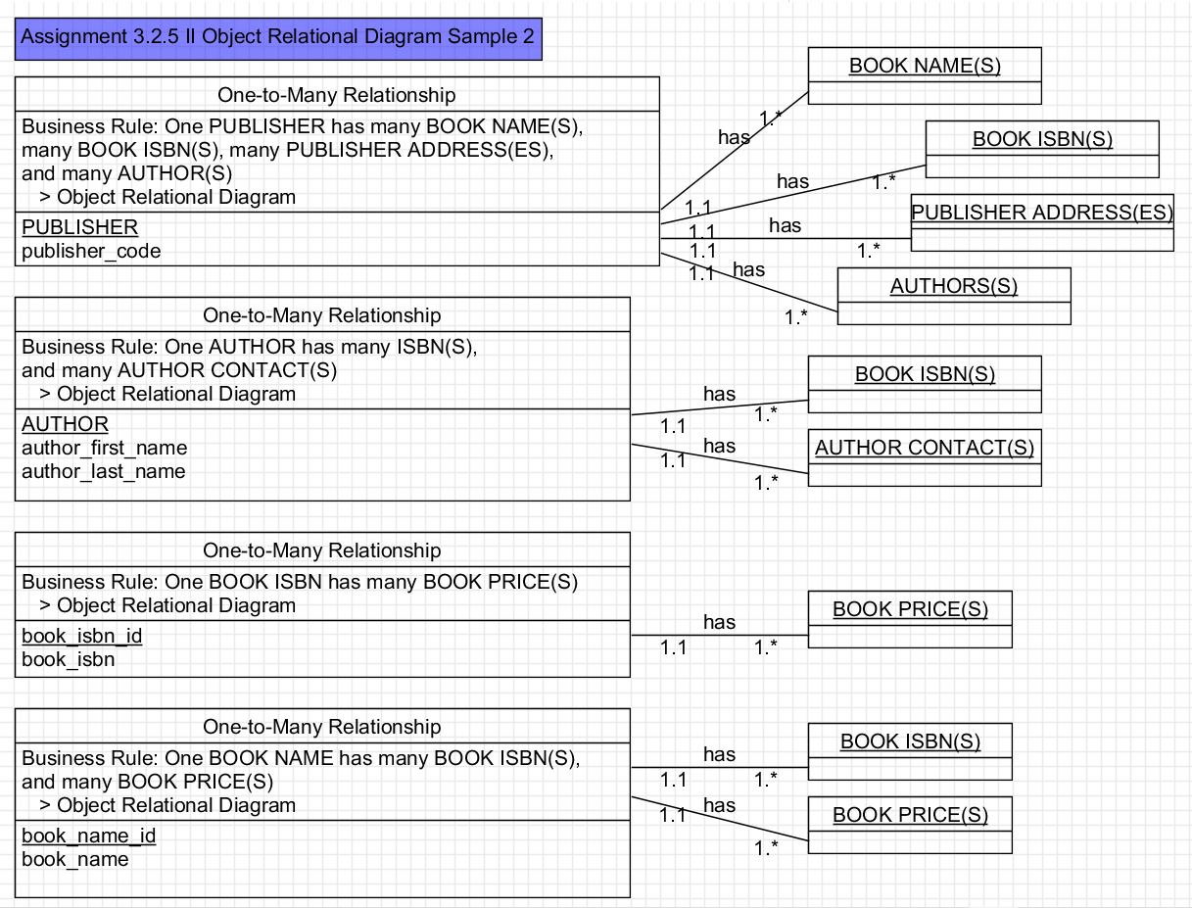

N/A. (2022). Data Model Design. *MongoDB*. Retrieved June 12, 2022, from,

<https://www.mongodb.com/docs/manual/core/data-model-design/>

N/A. (2022). Normalization of Database. Studytonight. Retrieved June 12, 2022, from,

<https://www.studytonight.com/dbms/database-normalization.php>

Sadalage, Pramod J. and Martin Fowler. (2013). *N*oSQL Distilled: A Brief Guide to the Emerging World of Polyglot Persistence*. Addison-Wesley.*